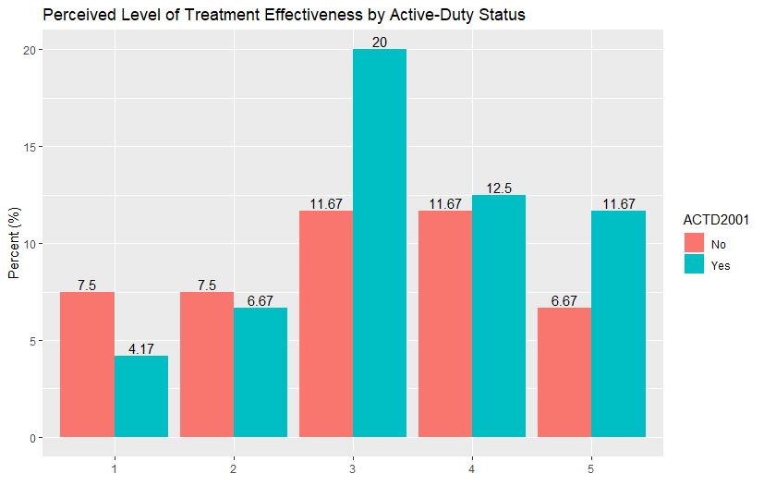Figure 1. Reported Satisfaction Level with Treatment Received for Depression (ADTMTHLP) in Terms of How Much Treatment Helped